POSITIVE NEGATIVE

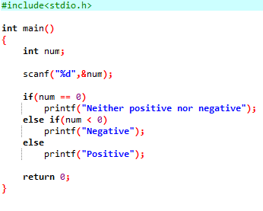

OUTPUT

